26.55: Circuit (a) 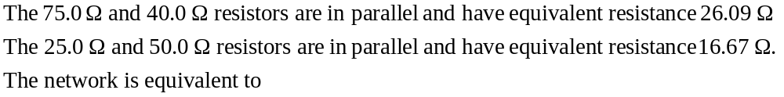
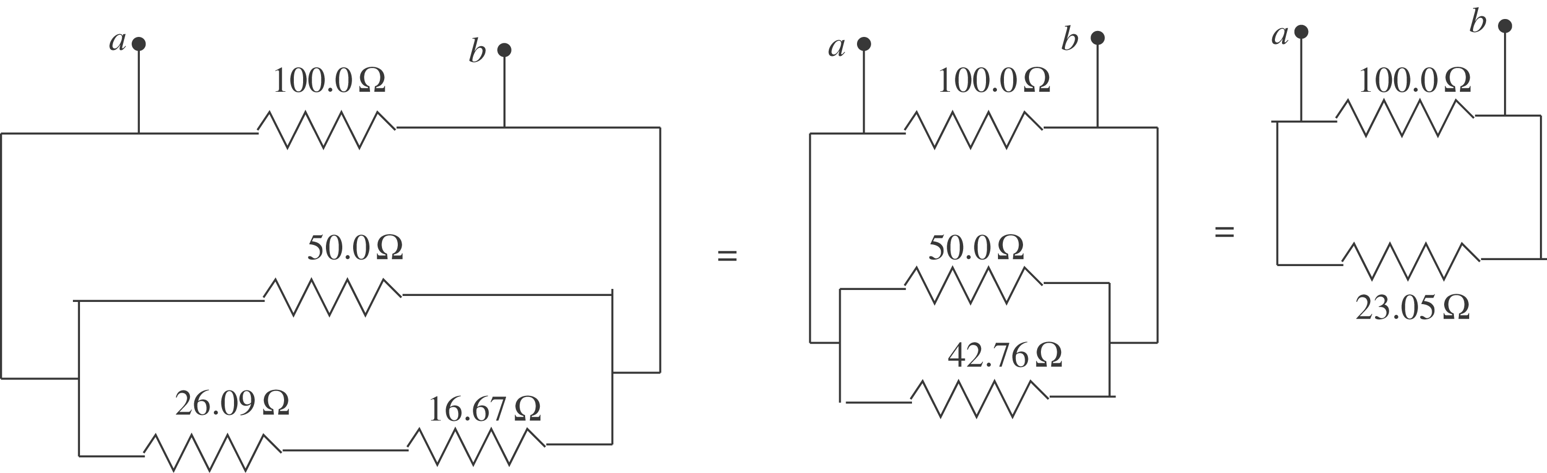
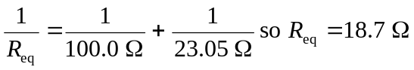
Circuit (b)
The .
The network is equivalent to
